Decision Tree
Decision Tree is one of the most powerful and popular algorithms. Python Decision-tree algorithm falls under the category of supervised learning algorithms. It works for both continuous as well as categorical output variables.
It has two types of algo= decision tree classifier, decision tree regressor.but its mainly used for classification.

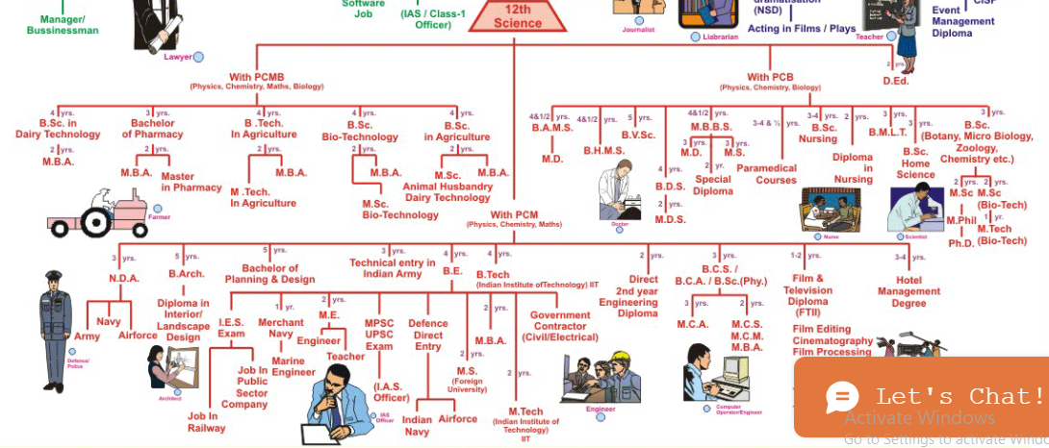
How DT works
A Decision tree is a tree-like structure that represents a set of decisions and their possible consequences. Each node in the tree represents a decision, and each branch represents an outcome of that decision. The leaves of the tree represent the final decisions or predictions.
Decision trees are created by recursively partitioning the data into smaller and smaller subsets. At each partition, the data is split based on a specific feature, and the split is made in a way that maximizes the information gain.

key Components of Decision Trees in Python
- Root Node: The decision tree's starting node, which stands for the complete dataset.
- Branch Nodes: Internal nodes that represent decision points, where the data is split based on a specific attribute.
- Leaf Nodes: Final categorization or prediction-representing terminal nodes.
- Decision Rules: Rules that govern the splitting of data at each branch node.
- Attribute Selection: The process of choosing the most informative attribute for each split.
- Splitting Criteria: Metrics like information gain, entropy, or the Gini Index are used to calculate the optimal split.

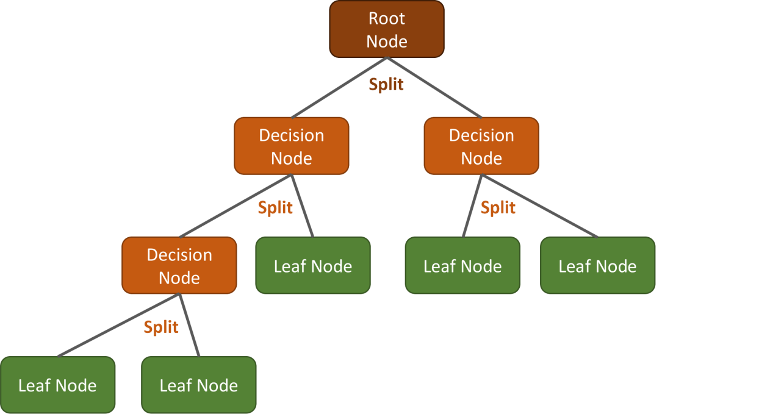

HOW ROOT NODE IS SELECTED
The root node in a decision tree is selected based on the feature that provides the "best split" of the data. This "best split" is determined by evaluating the effectiveness of each feature in separating the data into more homogeneous subsets with respect to the target variable. Different algorithms employ various criteria to quantify this effectiveness:
- Information Gain (ID3, C4.5 algorithms):
This metric measures the reduction in entropy (a measure of impurity or disorder) achieved by splitting the dataset on a particular feature. The feature that gives the highest information gain is chosen as the root node.

Entropy in a decision tree is a measure of impurity or uncertainty within a set of data, calculated using a specific mathematical formula from information theory
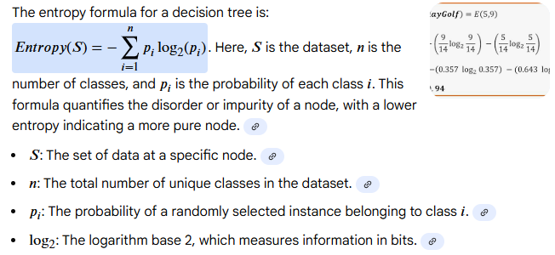

- Gini Impurity (CART algorithm):
Gini impurity quantifies the probability of misclassifying a randomly chosen element if it were randomly labeled according to the distribution of labels in the subset. The feature that results in the lowest Gini impurity after a split is selected.
- Gain Ratio (C4.5 algorithm):
Gain ratio is an extension of information gain that addresses its bias towards features with many distinct values. It normalizes information gain by the intrinsic information of the split, which considers the number and size of the resulting subsets. The feature with the highest gain ratio is selected.

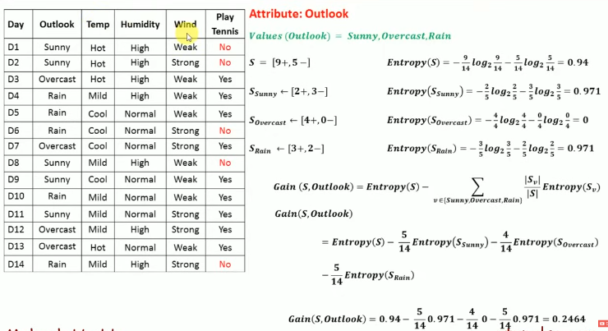

1. the attribute which gives maximum info gain will be root node
2. first calculate entropy of whole dataset it means for target column ,it is seen that it contains 9positive and 5 negative classes so based on it calculate entropy
3. now take one attribute as outlook in which possible values are three, sunny overcast and rain and calculate entropy for all three values using entropy formula
4. in this way calculate entropy values for each class present in all attributes.
5. put all the entropy values of each class into our information gain formula and calculate info gain for each attribute. And based on its value select attribute for root node
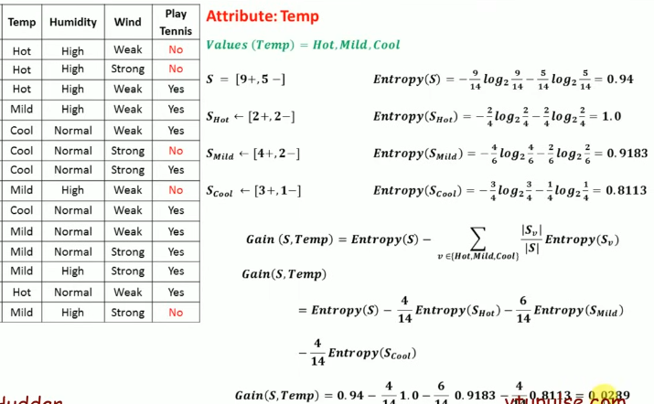

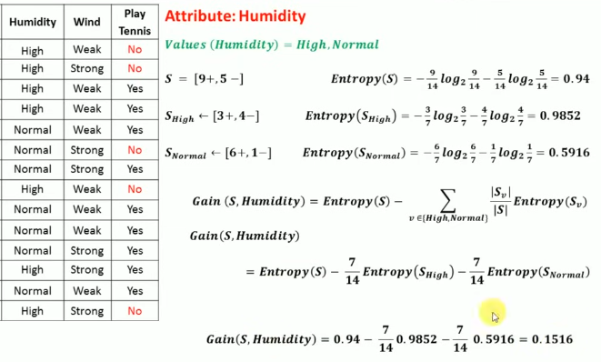

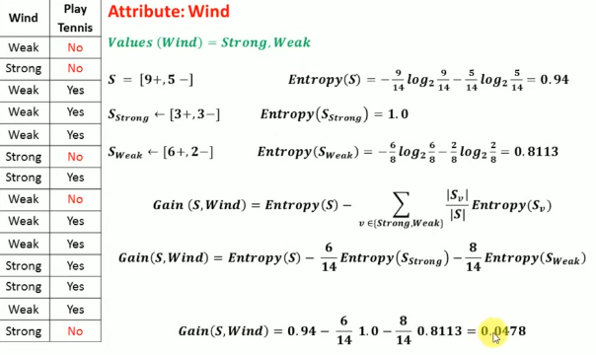

In this way we calculate information gain for each attribute and as below
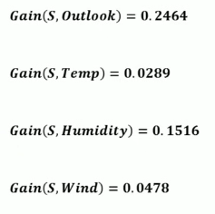
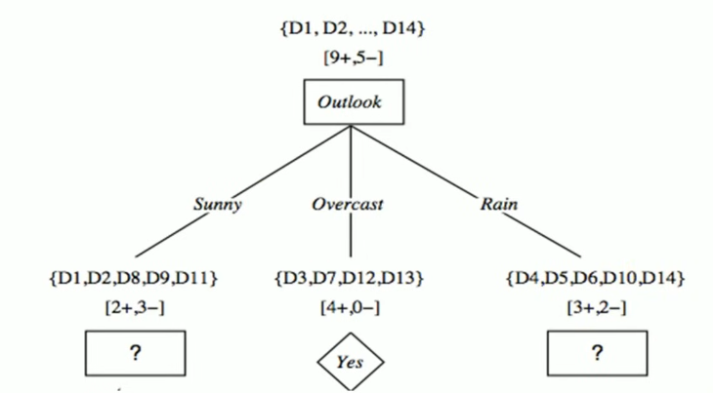

# ============================================
# DECISION TREE CLASSIFICATION - FULL PIPELINE
# ============================================

# 1. Import libraries
import pandas as pd
from sklearn.model_selection import train_test_split
from sklearn.tree import DecisionTreeClassifier, plot_tree
from sklearn.metrics import accuracy_score, classification_report, confusion_matrix
import matplotlib.pyplot as plt

# ----------------------------------------------------
# 2. Load your dataset
# (Replace CSV path or load any dataset you want)
# ----------------------------------------------------
df = pd.read_csv("data.csv")

# Example: assume the target column is "target"
X = df.drop("target", axis=1)
y = df["target"]

# ----------------------------------------------------
# 3. Split train/test data
# ----------------------------------------------------
X_train, X_test, y_train, y_test = train_test_split(
X, y, test_size=0.2, random_state=42
)

# ----------------------------------------------------
# 4. Create and train decision tree model
# ----------------------------------------------------
model = DecisionTreeClassifier(
criterion="gini", # or "entropy"
max_depth=None, # you can set depth limit
random_state=42
)

model.fit(X_train, y_train)

# ----------------------------------------------------
# 5. Make predictions
# ----------------------------------------------------
y_pred = model.predict(X_test)

# ----------------------------------------------------
# 6. Evaluate model performance
# ----------------------------------------------------
print("Accuracy:", accuracy_score(y_test, y_pred))
print("\nClassification Report:\n", classification_report(y_test, y_pred))
print("\nConfusion Matrix:\n", confusion_matrix(y_test, y_pred))

# ----------------------------------------------------
# 7. Visualize the Decision Tree
# ----------------------------------------------------
plt.figure(figsize=(16, 10))
plot_tree(model, feature_names=X.columns, class_names=True, filled=True)
plt.show()

